5th Grade Science
Standard | 3.0 Items
R5.5(A) classify matter based on physical properties, including mass, magnetism, physical state (solid, liquid, and gas), relative density (sinking and floating), solubility in water, and the ability to conduct or insulate thermal energy or electric energy;  (images have been sourced linked) | Option 1  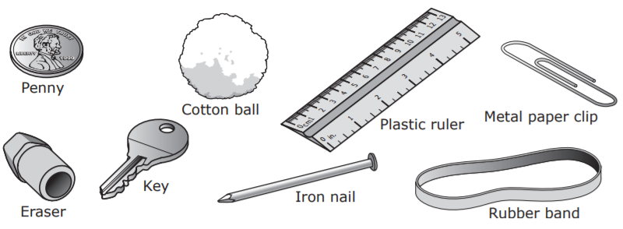  Science STAAR Test 2015 image  1a. Choose three of these items to sort least to greatest based on mass.  ____________________ ______________________ ______________________  1b. Classify these items based on their attraction to a magnet.  Item Attracted Not Attracted  Copper Penny  Rubber Eraser  Cotton ball  Brass Key  Plastic ruler  Iron nail  Metal paper clip  Rubber band  1c. Classify the following items based on their relative density.  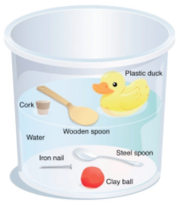  Item Less dense than water More dense than water  plastic duck  cork  steel spoon  iron nail  wooden spoon  clay ball  1d. Fill in the table with the answers to these testing questions:  - Does it have a fixed shape?  - Does it have a fixed volume?  solid liquid gas  Fixed shape  Fixed volume  1e. Classify the items based on their solubility.  Items Will dissolve in water Won’t dissolve in water  Marble  Sugar cube  Rice  Salt  Lemon juice  Toothpick  1f. Name two household items that are good conductors of electrical energy.  __________________ ___________________  1g. Name two household items that are good conductors of thermal energy.  __________________ ___________________  Option 2  Science STAAR Test 2015 image  1a. Which group of items is sorted from least to greatest by mass.  - key, cotton ball, rubber band  - rubber band, key, cotton ball  - key, rubber band, cotton ball  - cotton ball, rubber band, key  Science STAAR Test 2015 image  1b. Choose the object that is not attracted to a magnet.  - Iron nail  - Copper Penny  - Metal paper clip  - Brass Key  1c. Which object is less dense than water?  - Clay ball  - Wooden spoon  - Iron nail  - Steel spoon  1d. Which of the following physical states has a fixed volume, but not a fixed shape?  - Solid  - Liquid  - Gas  - All of the above  1e. Which groups of items will dissolve in water?  - Marbles, sugar cubes, and gravel  - Salt, lemon juice, and sugar  - Beans, rice, and salt  - Sand, toothpick, and cotton ball  1f. Which of these objects is a good conductor of electricity?  - Rubber  - Glass  - Metal  - Paper  -or-  1f. Copper wire is often wrapped in plastic. Plastic material is a good:  - Electromagnet  - Insulator  - Circuit  - Current  1g. What material does not allow heat to pass through easily?  - Cotton batting  - Aluminum foil  - Glass  - Steel  -or-  1g. Which of the following is a good conductor of thermal energy?  - Metal pot  - Styrofoam cooler  - Plastic container  - Wooden stick  Option 3  The table lists some properties of four different samples of matter.  Sample State of Matter at Room Temperature Mass of 1 mL of Sample Color Attracted to Magnet? Conducts Electricity? Conducts Heat? Dissolves in water? Sinks in water?  1 Solid 2.53g Clear No No No No Yes  2 Solid 7.87g Gray Yes Yes Yes No Yes  3 Liquid 0.94g Yellow No No Yes No No  4 Solid 1.59g White No No No Yes Yes  Which two samples could be glass marble and a sugar cube?  - Samples 1 and 2  - Samples 1 and 4  - Samples 2 and 4  - Samples 2 and 3  Answer B  Sample 1 is consistent with the properties of glass. Sample 4 is consistent with the properties of a sugar cube. Sample 2 may be an object such as an iron cube, and Sample 3 may be a substance such as vegetable oil.
 | 2.0 Items
Option

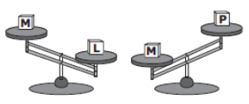
Science STAAR Test 2016 image

Which block has the greatest mass?

- Block L
- Block M
- Block P
- Block L and Block M

Option

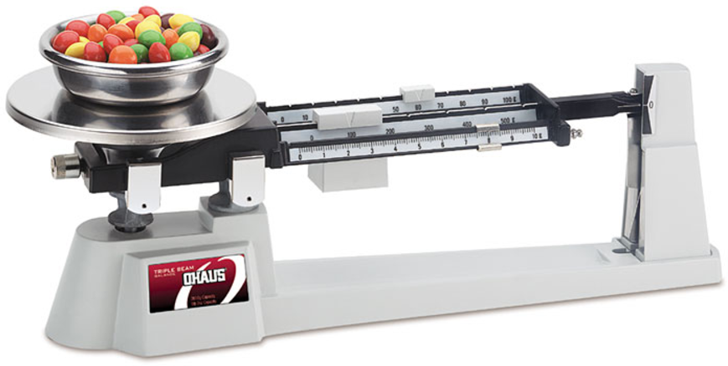
What physical property of matter is being tested above?
- Physical state of matter
- Mass
- Temperature
- Solubility

Option

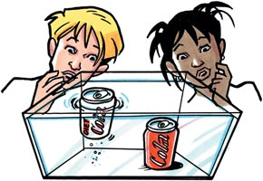

________ can be shown by the sinking and floating of objects in water.
- Mass
- Volume
- Density
- Matter

Option

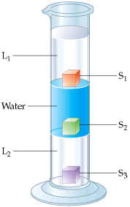

Which liquid is the least dense?
- L1
- Water
- L2
- S2

Option

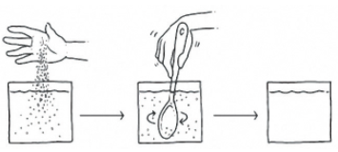
A student adds solid particles to water. What happened to the particles?

- The particles evaporated.
- The particles are soluble and dissolved in the water.
- The particles sank because they are more dense than water.
- None of the above.

Option

When black sand and iron filing are mixed together they look like a black powder. Which of the following would be the easiest way to separate the sand and the filings?
  - Use a magnifying glass
  - Add water to the mixture
  - Use a magnet
  - Use a hot plate to heat the mixture

Option

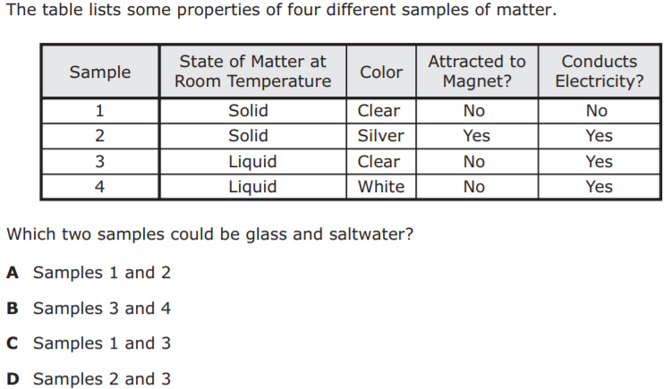

Option

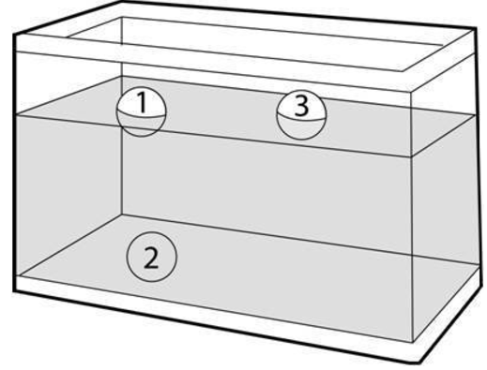

Which property of matter is being demonstrated in the diagram above?
- Mass
- Magnetism
- Density
- Matter

Option 1

paper cup | metal cup | ceramic glass cup
cool to touch | hot to touch | warm to touch

Sally pours hot chocolate into 3 different cups. Which cup is the best insulator of thermal energy?

- The paper cup
- The ceramic glass cup
- The metal cup
- The cups are all insulate the same

Option 2

paper cup | metal cup | ceramic glass cup
cool to touch | hot to touch | warm to touch

Explain why the manufacturer of the metal and glass cup might have included a handle in the design of their cups.

Option

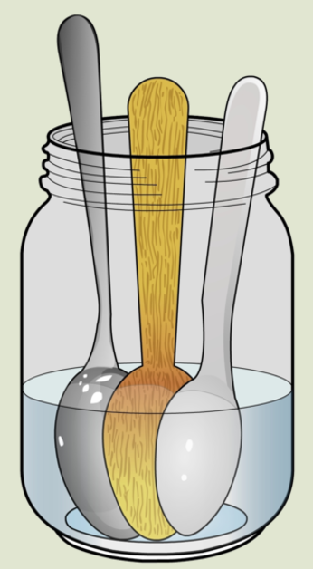
Three spoons were placed in a jar of warm water for five minutes. Which spoon best conducts thermal energy?
- Metal spoon
- Wooden spoon
- Plastic spoon
- All of the above

Option

What is a conductor?
- Amount of space on object takes up
- How hot or cold an object is
- Something that easily allows the flow of energy through it
- A physical state of matter

Option

What is an insulator?
- A physical state of matter
- Something that does not allow the easy flow of energy through it
- How hot or cold an object is
- Ability to sink or float in water

Option
James found his birthday present wrapped and hidden in his grandmother’s closet. He wanted to find out what was in the box without opening it. Using his scientific skills he found out his present had these properties:
- It rolls
- It bounces
- Not attracted to a magnet
- Is a solid
- Is larger than 20 cm

What might his present be?
- Basketball
- Baseball
- Toy car
- A glass marble

Standard | 3.0 Items
S (B) identify the boiling and freezing/melting points of water on the Celsius scale;energy; | 1a. Which of the following thermometers shows water in a solid state of matter?  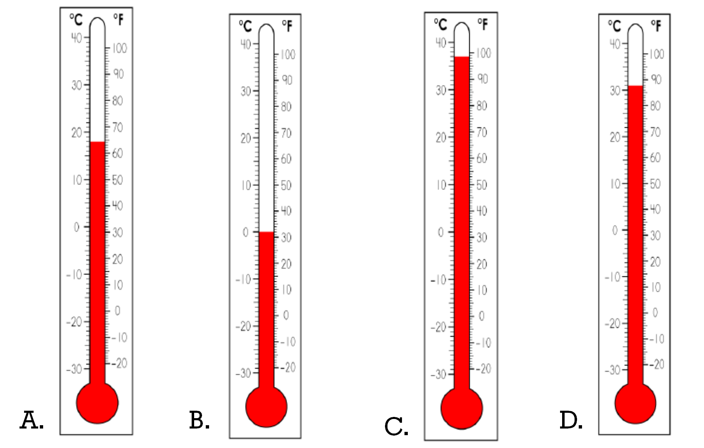  1b.  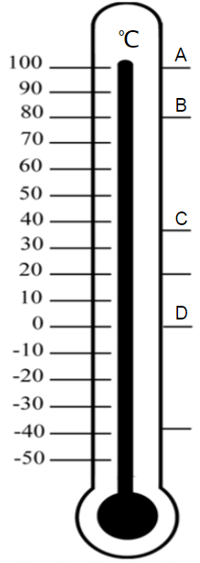  Which letter represents the boiling point of water?  - A  - B  - C  - D
 | 2.0 Items
Record the temperature for each thermometer.
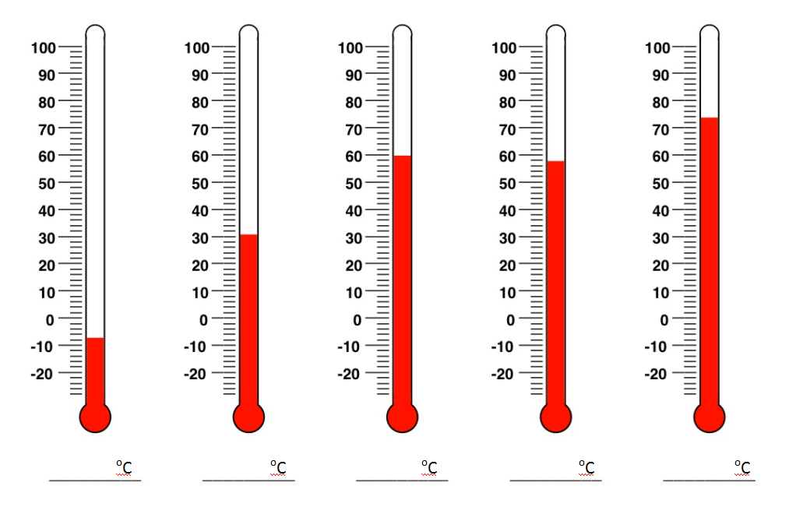

Standard | 3.0 Items
S(C) demonstrate that some mixtures maintain physical properties of their ingredients such as iron filings and sand; and | Option 1  Gary dropped steel fishing hooks in the sand. What are some ways that Gary could get the steel hooks out of the sand?  Option 2  Gary dropped steel fishing hooks in the sand. What is the best tool to use to separate the hooks from the sand?  - magnet  - tweezers  - spoon  - coffee filter  Option 1  Melissa mixes salt and pepper together for a project and wants to be able to separate the mixture after completing the project. Jesse suggests adding water, how could adding water help separate the salt and pepper? Explain what would happen.  Option 2  Melissa mixes salt and pepper together for a project and wants to be able to separate the mixture after completing the project. What is the best tool to use to separate the pepper from the salt?  - Tweezers  - Spoon  - Water  - Coffee filter
 | 2.0 Items
Option
Which of the following is an example of a mixture whose ingredients keep their physical properties?

a. Vanilla ice cream
b. Fruit salad
c. Blueberry muffins
d. Chocolate chip cookies

Option
What is a mixture?

Option
What is the best way to separate a mixture of sand and iron filings.
- Use a filter paper to catch the sand
- Use a magnet to catch the iron filings
- Use tweezers to pick out the iron filings
- Use a sieve to trap the iron filings

Standard | 3.0 Items
S (D) identify changes that can occur in the physical properties of the ingredients of solutions such as dissolving salt in water or adding lemon juice to water. | Option  Mario poured a packet of cocoa powder into a cup of hot water. He finished half of the cup. A week later, he found the cup and observed the changes that occurred. What happened to the cocoa mixture in the cup?  - The cocoa evaporated, leaving only clear water in the container.  - The water evaporated, leaving only a dry brown solid in the container.  - The container was empty after the mixture evaporated into the air.  - The cocoa in the cup was lighter in color after some of the water evaporated.  Option  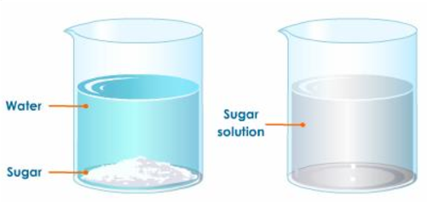  What happened to the sugar crystals?  - The sugar crystals evaporated  - The sugar crystals dissolved  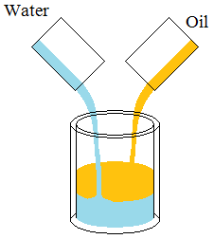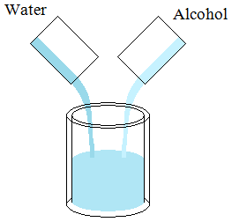  Which mixture is a solution and which on is not?  Explain your reasoning.
 | 2.0 Items
Option
A solution is a type of
- Problem
- Liquid
- Mixture
- Force

Option
When one substance is dissolved into another substance, it is known as
- Force
- Solutions
- Problems
- Insulator

